**Assignment – 6**

Assigned To = Mradul Tiwari , Yuvraj Singh Tomar , Sachin Baghel, Mohit Pathak

**Chapter = Lines and Angles**

**Submission Date = 30 July 2022 MM = 30**

Q1. ****If an angle is 30° more than one half of its complement, find the measure of the angle?****

Q2. ****Two supplementary angles are in the ratio 4:5. Find the angles?****

Q3. ****Two supplementary angles differ by 480. Find the angles?****

Q4. ****An angle is equal to 8 times its complement. Determine its measure?****

****Q5. In figure, rays OA, OB, OC, OD and OE have the common end point 0. Show that ∠AOB+∠BOC+∠COD+∠DOE+∠EOA=360°.****

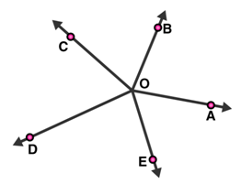

Q6. ****In figure, I, m and n are parallel lines intersected by transversal p at X, Y and Z respectively. Find ∠1, ∠2 and ∠3.****

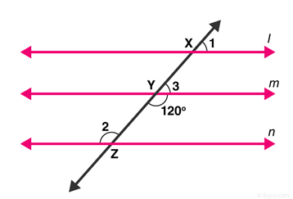

Q7. ****In figure, AB || CD || EF and GH || KL. Find ∠HKL.****

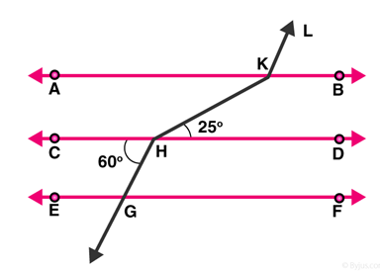

Q8. ****In figure, show that AB || EF.****

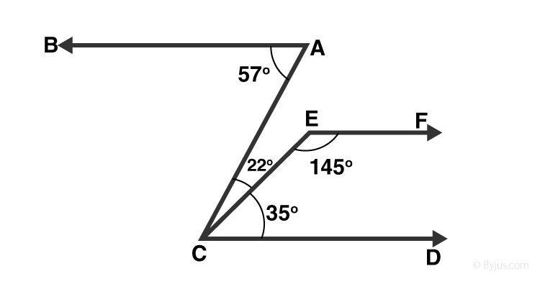

Q9.  In the given figure, POQ is a line. Ray https://www.careerlauncher.com/cbse-ncert/class-9/9-math-lines-Ang-hot-UntitOE4.JPG is another ray lying between rays https://www.careerlauncher.com/cbse-ncert/class-9/9-math-lines-Ang-hot-UntitOE5.JPG and https://www.careerlauncher.com/cbse-ncert/class-9/9-math-lines-Ang-hot-UntitOE6.JPG Prove that

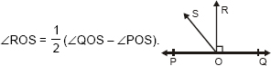

**Q10. n the given figure, lines Ab, CD and EF intersect at O.**

**Find the measure of ∠AOC, ∠COF.**

